Restaurant Case Study UseCase ( Using Hadoop and PySpark)

1. Global Cuisine Popularity Analysis
The Problem: The Cuisines column contains comma-separated values (e.g., "French, Japanese, Desserts").
Goal: Calculate the total count of each cuisine globally and per city to identify the most popular food types.
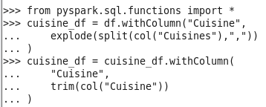
The total count of each cuisine globally
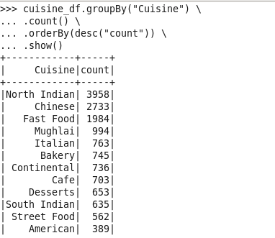
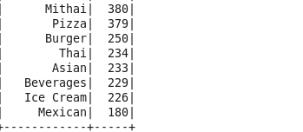
The total count of each cuisine per city
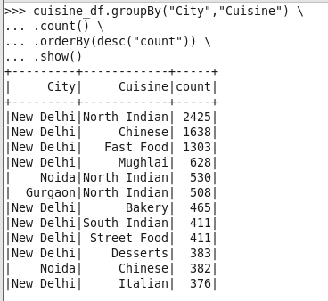
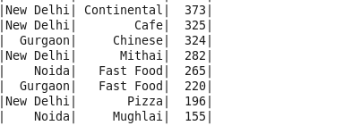
2. Normalizing and Comparing Costs Across Currencies
The Problem: The Average Cost for two is in different local currencies (INR, Dollar, Botswana Pula, etc.).
Goal: Determine which city/country has the most expensive or affordable dining scenes on a global scale.
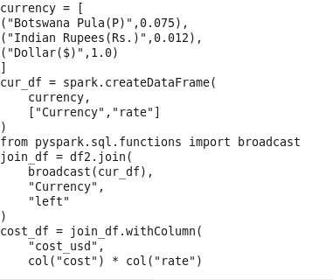

city the most expensive or affordable dining scenes on a global scale.

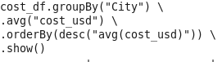
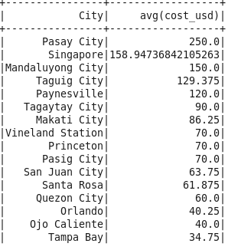
Country the most expensive or affordable dining scenes on a global scale.
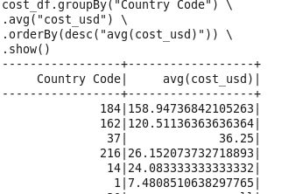
3. Impact of Services on Customer Ratings
The Problem: Does having "Online Delivery" or "Table Booking" actually lead to better reviews?
Goal: Provide business insights into whether investing in delivery infrastructure correlates with higher customer satisfaction.
Has online delivery
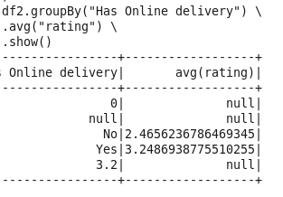
Has table booking
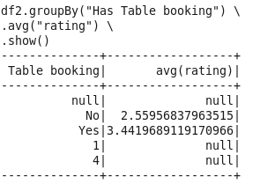
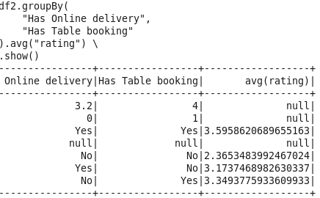

4. Identifying "Hidden Gems" (Weighted Rating Analysis)
The Problem: Some restaurants have a 5.0 rating but only 2 votes, while others have 4.5 with 2,000 votes.
Goal: Find highly-rated restaurants that have significant customer trust.

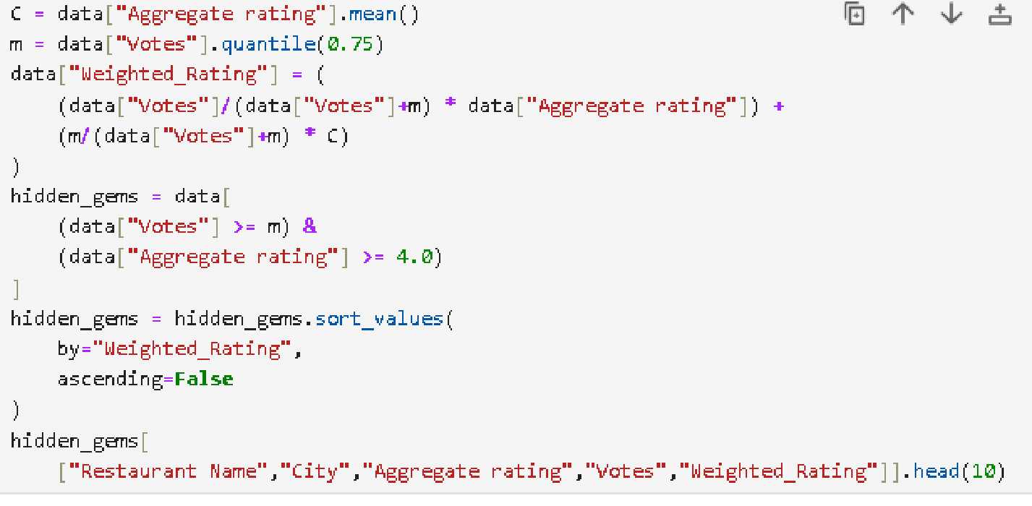
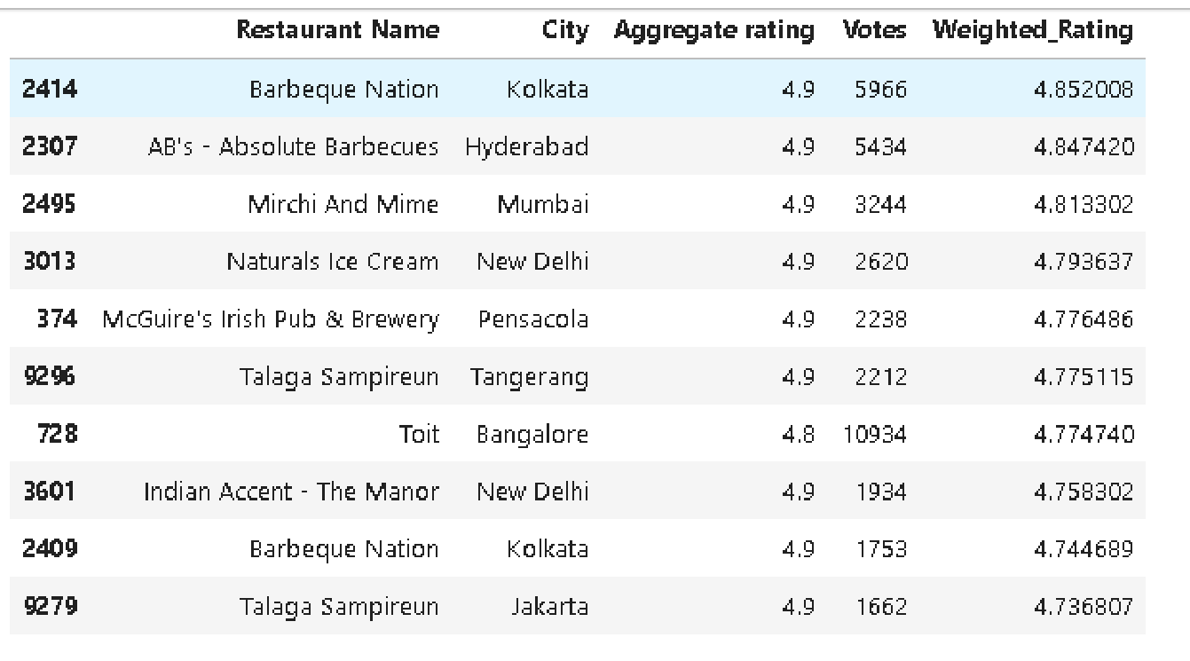
5. Restaurant Clustering for Marketing (PySpark MLlib)
The Problem: Grouping restaurants for targeted advertisements.
Goal: Categorize restaurants into segments like "Luxury Dining," "Budget Eats," and "Popular Mid-range."
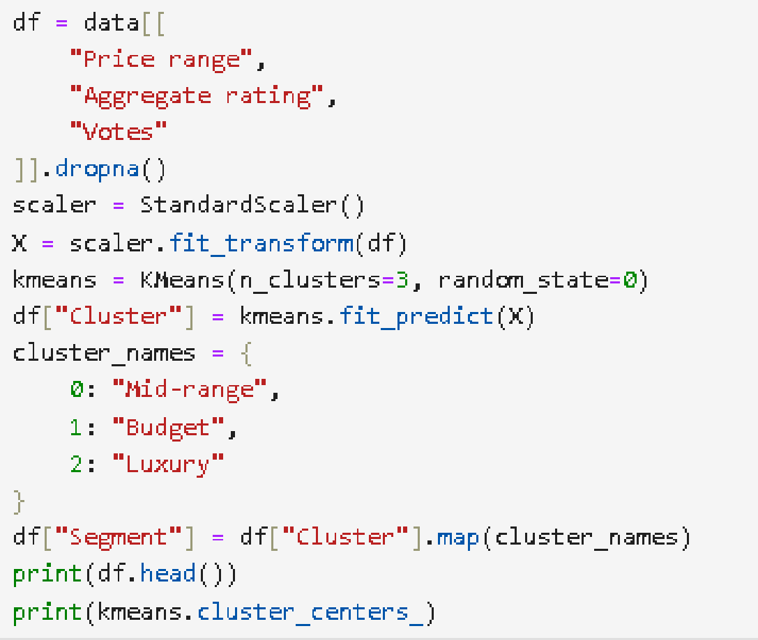
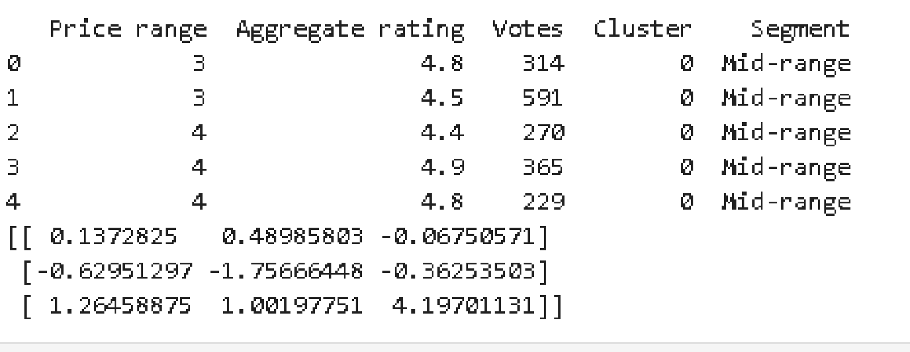
6. Geolocation-based Food Hub Detection
The Problem: Identifying dense clusters of restaurants (Food Hubs) without relying on locality names.
Goal: Identify the exact geographic areas where restaurant competition is highest
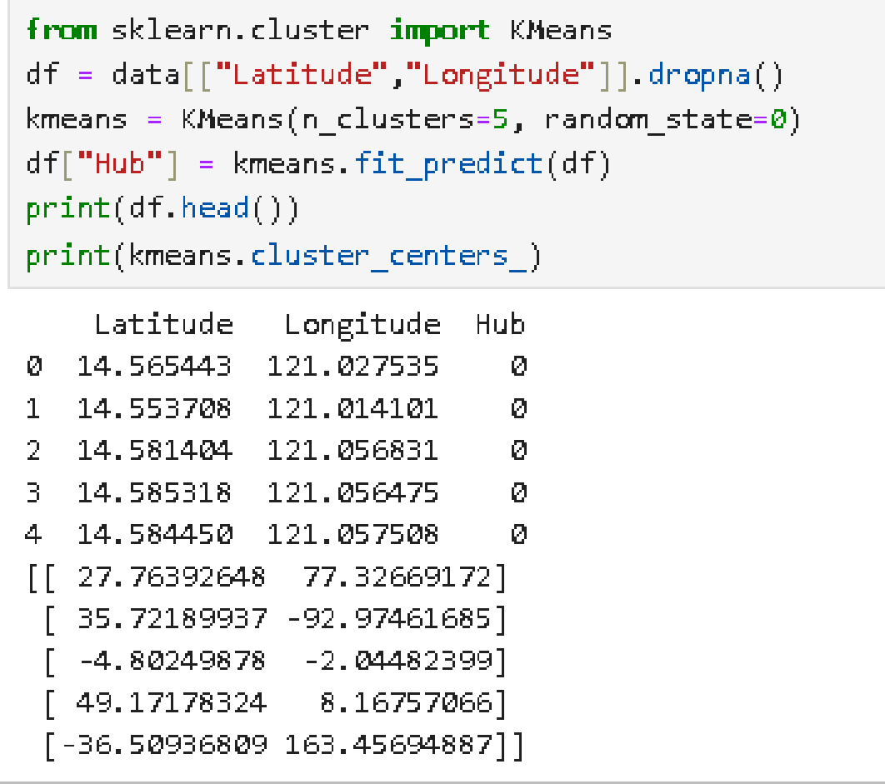
7. Data Quality & Standardization Pipeline
The Problem: The dataset contains null values in Cuisines and potential encoding issues in city names.
Goal: Ensure the data is "Analytics Ready" for downstream business intelligence tools.
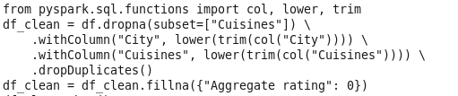
8. Locality-wise Price Range Distribution
The Problem: Analyzing the economic profile of different neighborhoods.
Goal: Generate a report showing the percentage of "Cheap" vs "Expensive" restaurants in every locality to help new entrepreneurs find market gaps.
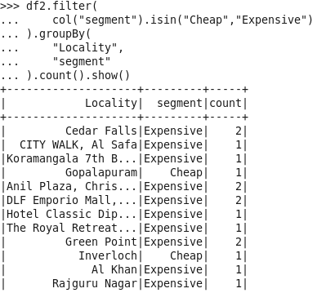
9. Price Range Prediction (Classification)
The Problem: Can we predict the Price range (1 to 4) of a new restaurant based on its location and cuisine?
Goal: Build a model that predicts the category of a restaurant based on its basic profile.
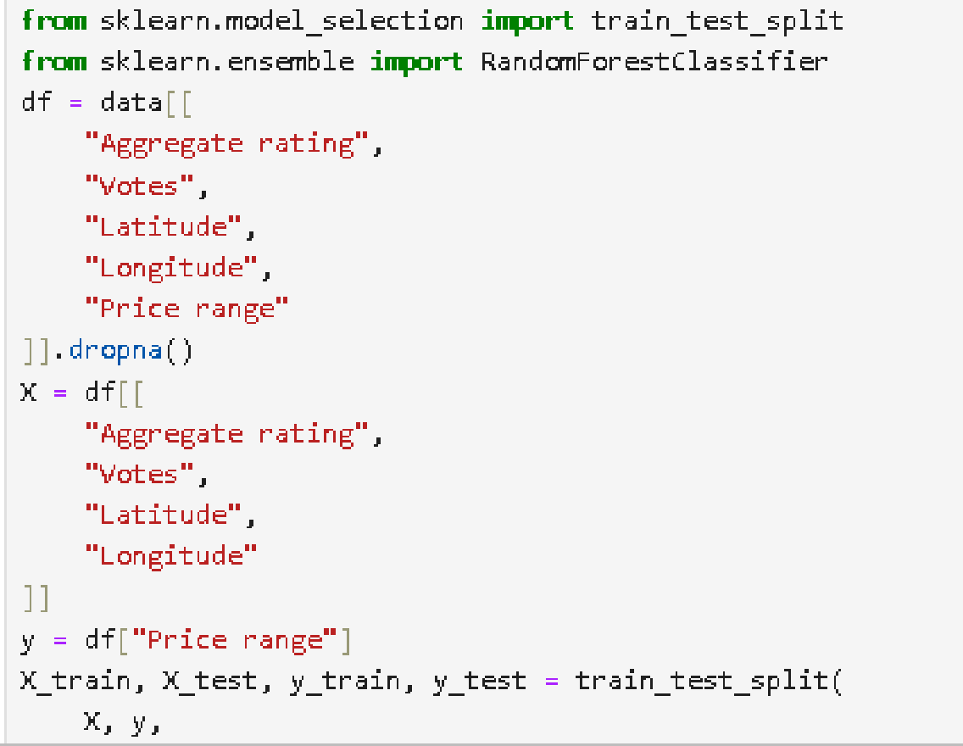
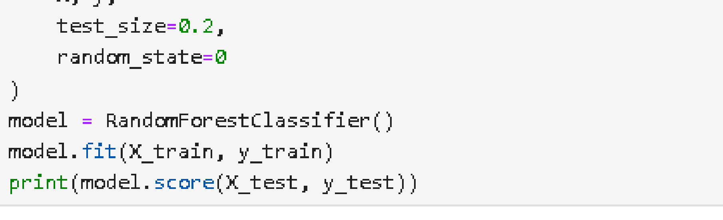

10. Top-N Recommendation Engine (Content-Based)
The Problem: Recommending similar restaurants to a user.
Goal: Given a restaurant the user likes, recommend 5 other similar restaurants in the same city.

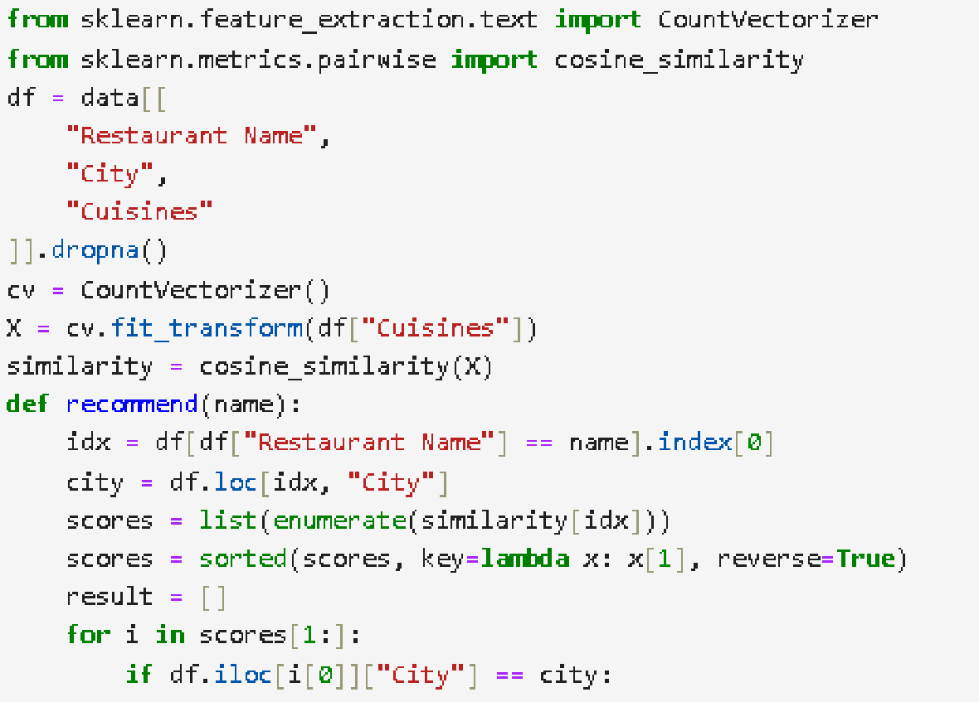
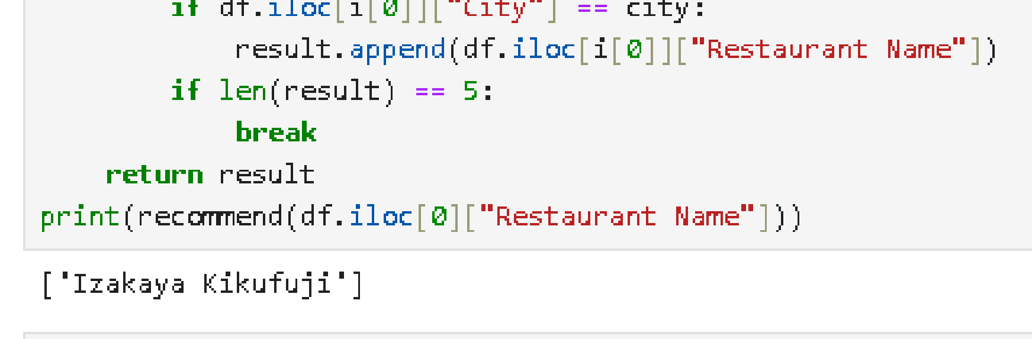
11. Optimized Currency Conversion (Broadcast Join)
The Problem: Joining a massive restaurant dataset with a tiny 15-row currency exchange table triggers a standard shuffle join, moving millions of rows across the network unnecessarily
Goal: Implement a Broadcast Join to eliminate network shuffle and speed up the cost
normalization process across different global currencies.
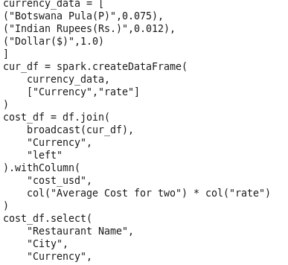
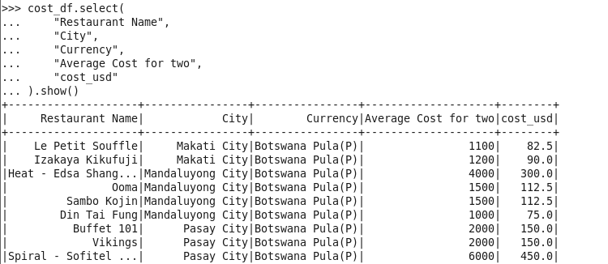
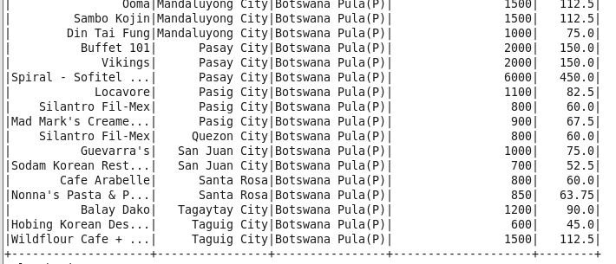
12. Efficient Data Pipelines (Caching & Storage)
The Problem: The "Cuisine Popularity" analysis and "Price Range Prediction" both use the same cleaned dataset. Without optimization, Spark re-reads the raw CSV from HDFS and re-calculates the split() and explode() transformations for every single query.
Goal: Use .cache() to persist intermediate cleaned data in memory and save the final "Analytics Ready" dataset in Parquet format to leverage columnar storage and compression.

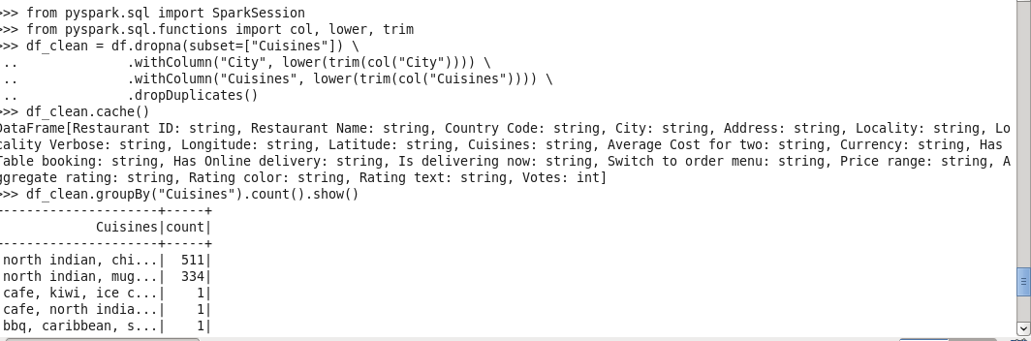
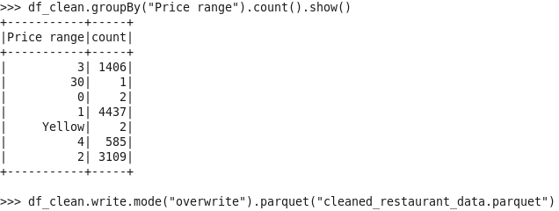
13. Service Impact Comparative Visualization
The Problem: Simply listing the average rating for restaurants with "Online Delivery" vs. "Table Booking" doesn't show the full story of customer satisfaction or the volume of feedback.
Goal: Create a Side-by-Side Box Plot to compare rating distributions for each service, using Color Overlays to represent different price ranges and Point Density (Jitter) to show the total number of votes.

